GEN_AI LAB 13
Using LLMs for Code Generation and Bug Detection in Software Development
Name: Shiva Dhanush S
USN: 1RVU23CSE428
Date: 08-04-2026
Introduction
This lab was implemented with the free local `qwen2.5-coder:3b` model running through Ollama. The workflow demonstrates both code generation and bug detection, followed by verification of the corrected Python code.
Objective
- To generate Python code from a software requirement prompt.
- To identify a logical bug in faulty source code using an LLM.
- To obtain a corrected version of the program and run it locally.
- To capture notebook-style evidence for all major outputs.
Tools and Platforms Used
Tool / Platform | Purpose in the Experiment
Ollama | Used to run the local coding model.
qwen2.5-coder:3b | Free code-generation and debugging model used in the experiment.
Python | Used to execute the corrected code for verification.
Jupyter Notebook | Used to organize the prompt-response workflow.

Methodology / Procedure
- Ask the coding model to generate a StudentRecordManager class from a textual requirement.
- Provide a faulty average-calculation program and request a bug explanation plus fix.
- Extract the corrected code and run it with Python for verification.
- Store the outputs in the notebook and export them as screenshot evidence.
Implementation / Workflow Summary
The generated program correctly introduced a `StudentRecordManager` class with methods for adding students, computing class average, and listing passed students. For the debugging task, the model identified the off-by-one loop error in the faulty averaging function and proposed a correct replacement.
The corrected program was executed locally and produced the output `20.0`, confirming that the fix works in practice.
The executed notebook file is stored at: C:\Users\licha\OneDrive\Desktop\Gen-AI\output\jupyter-notebook\lab_13_code_bug_detection_428.ipynb
Screenshot Evidence
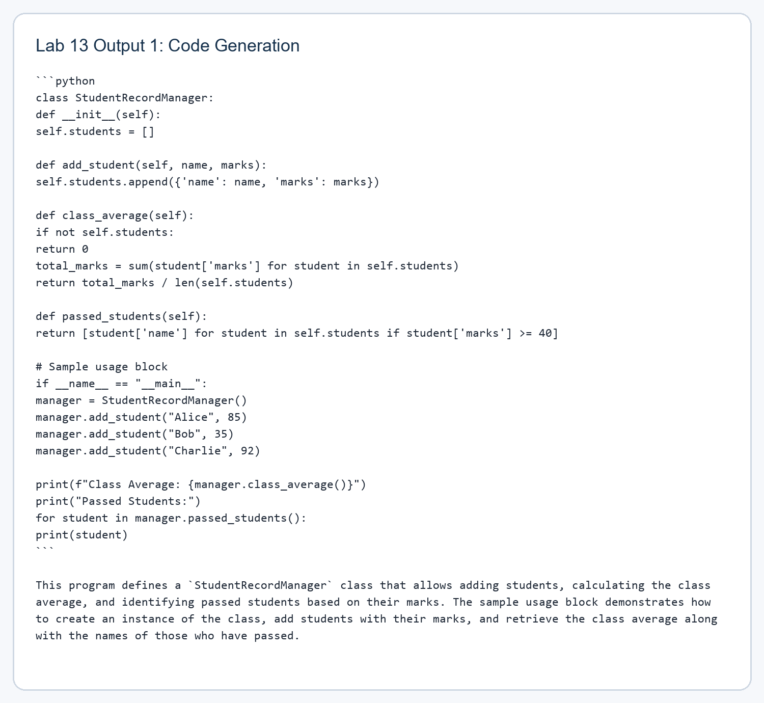
Figure 1. Captured output from the Lab 13 code-generation and bug-fixing workflow.
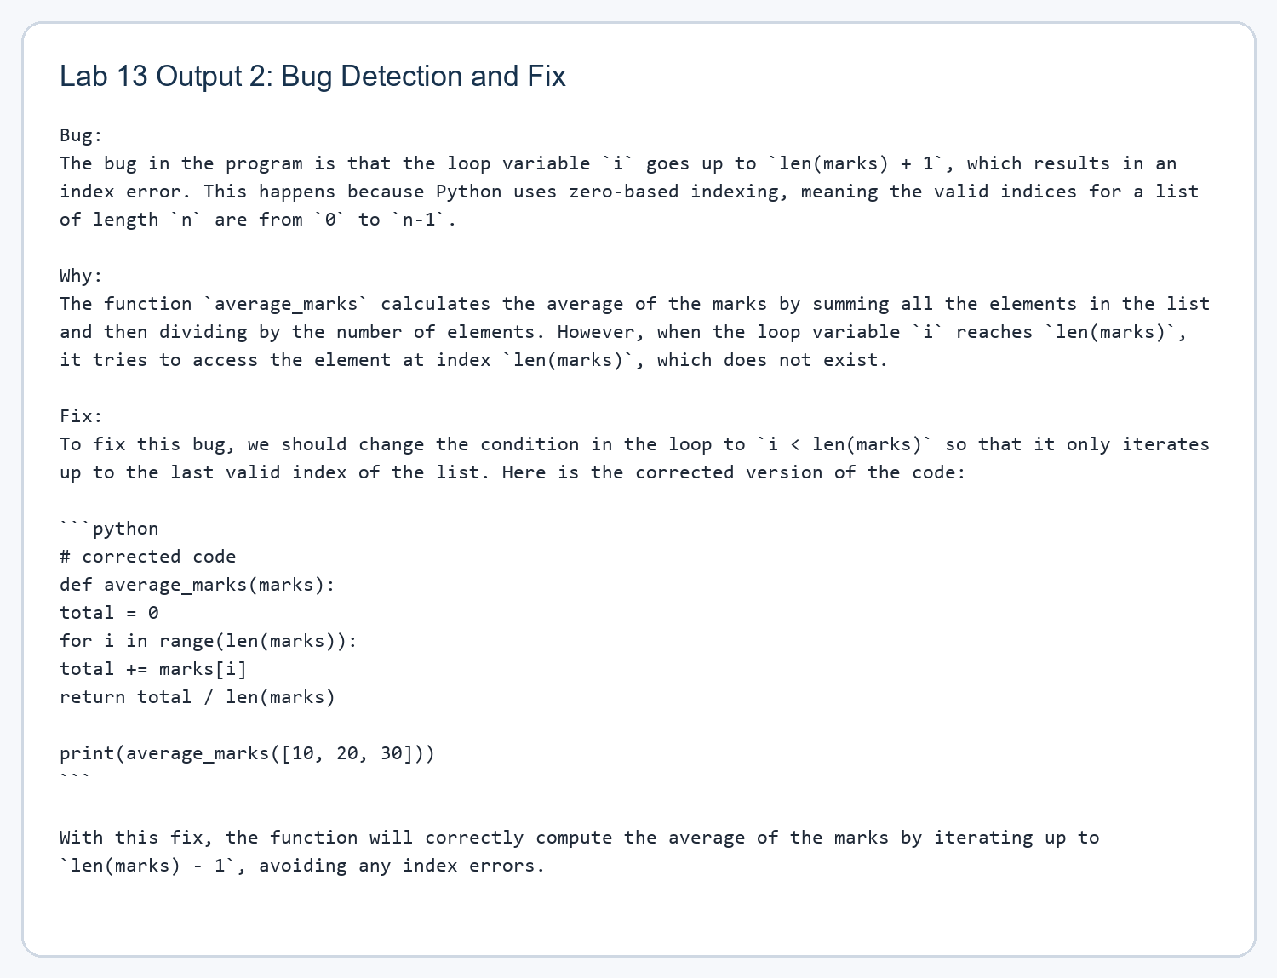
Figure 2. Captured output from the Lab 13 code-generation and bug-fixing workflow.
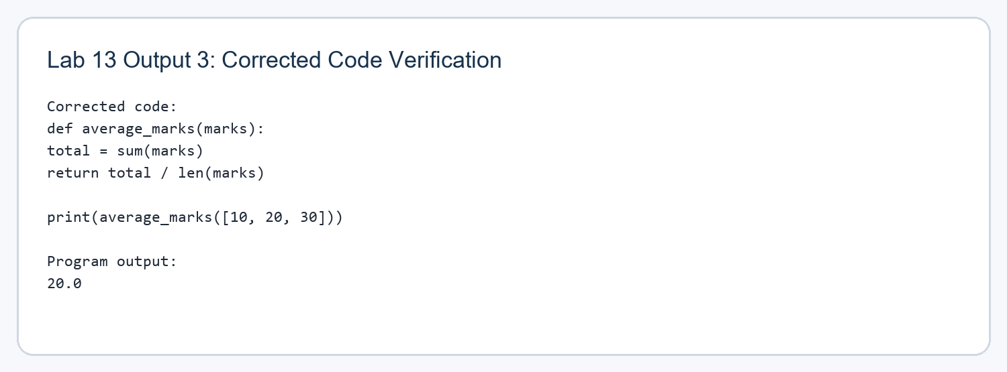
Figure 3. Captured output from the Lab 13 code-generation and bug-fixing workflow.
Observations
The model was effective for both requirement-to-code generation and reasoning about a runtime bug. In the verification phase, the final corrected function was even simplified further by replacing manual looping with Python's built-in `sum()` operation.
This experiment also shows why human validation remains important: the generated answer must still be executed and reviewed before being accepted as correct software behavior.
Result / Conclusion
The lab was completed successfully using a free local coding model. Real outputs were generated for code creation, bug analysis, and corrected-code verification, and those outputs are embedded in this report as evidence.

